# 



**Kingdom of Saudi Arabia**

**Ministry of Education**

**King Faisal University**

**College of Computer Sciences & Information Technology**

**IS222: Database Concepts & Design**

**Course Project Report**

HFIA

## SECTION[63]

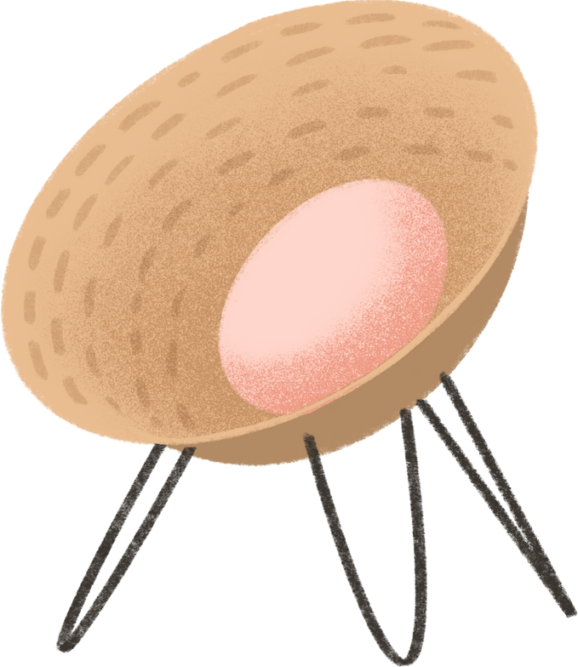

## GROUP MEMBERS

**Group Members**

|  |  |  |
| --- | --- | --- |
| **Student Name** | **Student ID** | **Contribution** |
| Hissah Alwasifer | 219025504 | Her contribution to the project |
| Noura Almosened | 219010636 | Her contribution to the project |
| Ghaida Alarfaj | 219009389 | Her contribution to the project |
| Latifah Alhatlan | 219029556 | Her contribution to the project |

### INTRODUCTION:

**Most people find they enjoy traveling for this reason we interstand to create a database for those who like and enjoy traveling to reduce their travel money to have a tour guide.**

**HFIA ‘have fun in Alahsa’ is a database for tourist guides which will have all of Al-Ahsa's places to guide the tourists instead of paying for a tour guide.**

### EXAMPLE:

**);**

**(**

**admin_id    VARCHAR2(9)   NOT NULL  CONSTRAINT  pk_adminID  PRIMARY KEY (admin_id)**

**admin_name   VARCHAR2(25)  NOT NULL,**

**salary       NUMBER     NOT NULL CONSTRAINT admin_salary CHECK (salary >= 6000 AND salary <= 40000),**

**address  VARCHAR2 (40) NOT NULL,**

**);**



.

# EXAMPLE:

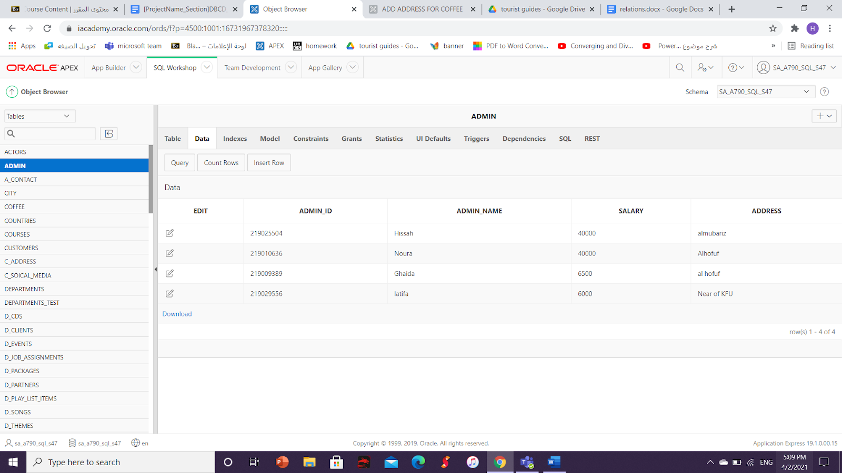



AHMAD WANTS TO LIST STORES THAT HAVE  RATE >2.3

### 



## INTERFACE:



## 



END.